**Assessment 2: Team Project  
Group 1: Pseudo Boomers**

<https://github.com/Jake-Patrick/IIT-Assignment-2-Group-Work-Repository>  
  
<https://jake-patrick.github.io/IIT-Assignment-2-Group-Work-Repository>

Team Profile

**Personal Information**

Our group ‘No Idea’ come from a diversity of backgrounds. We all have quite different personal and professional histories, as well as hobbies, interests and experience levels in IT. We also have a lot in common, considering our different backgrounds, and in particular, we all share an interest in IT, with some members, already working in the industry. We each hope to take our university learning and put it to use in starting new careers or incorporating it into our existing careers.

Our group ‘No Idea’ consists of Benjamin Saar (s3856805), Jacob Patrick (s3873028), Jordan O’Meara (s3879432), Murray Nesteroff (s3880001), Sneha Sathpathy (S3871459) and Rajaneesh Sankaran Nair Sukumarai Amma (s3871492).

***Benjamin Saar***

 (Ben) is 23 years old and lives in the Dandenong Ranges just east of Melbourne, Victoria. He is currently working as a Service Technician for an IT company in Melbourne and has been doing so for just shy of two years. He has spent many years of his life playing a multitude of sports. He played soccer for around 18 years, only stopping when he started full-time work. From an IT perspective however, he has always had an avid passion for technology. Whether it be messing with bits of hardware and building PC’s or just playing games, technology has always been there. Working in a more technical space and getting to work in a business environment has really opened his eyes to the limitless possibilities that IT has, and how it can be used to make life easier for all.

***Jacob Patrick***

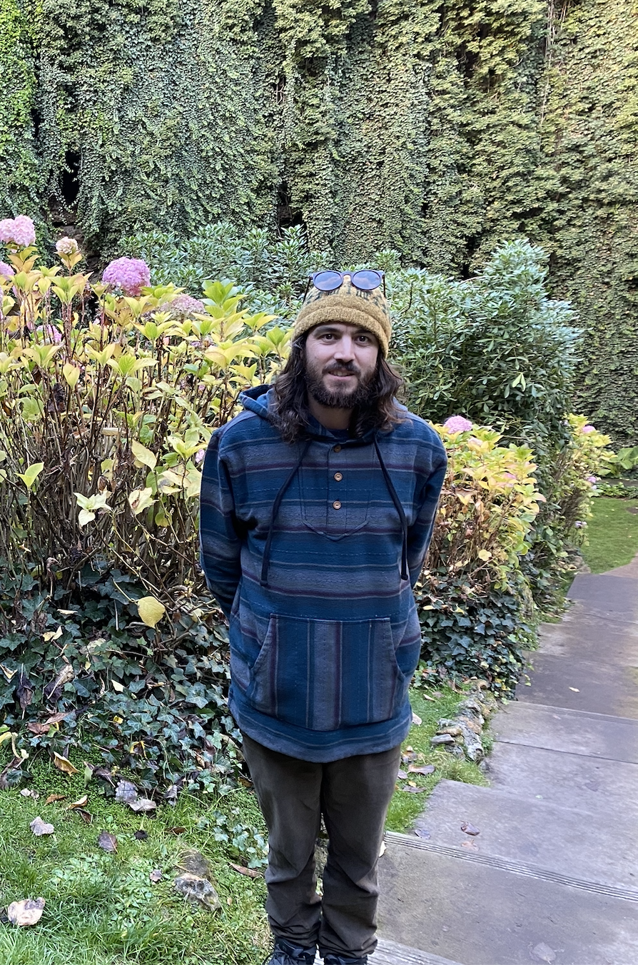Jake lives in the Fleurieu Peninsula region near Adelaide, South Australia. He comes primarily from a hospitality background and has also dabbled in other areas including aquaculture, horticulture, farm labouring and manufacturing. His interests include traveling, gardening, cooking and tinkering with old gaming consoles. He first became interested in IT as a career while traveling when he realised that it is possible to work from anywhere in the world using only a laptop and an internet connection. Recent world events have highlighted to him the importance of being adaptable he is keen to forge a future for himself that will allow more freedom and options in his life.

***Jordan O’Meara***

******Jordan is a 29-year-old Father of one based in regional Victoria, Australia. He has been interested in IT for as long as he can remember, always tinkering with hardware and software throughout his childhood. Although his experience with IT and computers is entirely non-professional, he believes that the familiarity he has built with technology over the years gives him an advantage when learning new things in the IT space.

***Murray Nesteroff***



Murray lives in the Inner West in Sydney, NSW. His first professional role was at a butcher shop for 5 years, where he learnt a few things about life. It took him a while to realise that it wasn’t for him and after a few other jobs, including working at a Samsung mobile store, he landed at the telco that he is currently work for. His interests include sport, photography and travelling. He loves spending time in the country away from the busy city just to recharge. He has had an avid interest in IT ever since he built his first gaming PC at a young age. Murray believes that IT is an amazingly broad industry with incredible opportunities, and he can’t think of making his profession in any other field.

***Sneha Sathpathy***

Sneha lives in Melbourne, Vic and is a dedicated wife, mother of two, and a full-time corporate woman working at the Department of Premier and Cabinet (VIC) within the IT Division. Having an Indian origin, she was brought up in New Zealand and then moved to Brisbane, where her family decided to settle down. There, she completed a Bachelor of Justice and an Advanced Diploma in Business Management. She took up a career in Information Technology after majoring in Psychology. Sneha’s perspective on life is that “you can never be too small or too big for anything, if you set your mind on achieving those goals”, and as if her life were not busy enough already, she decided to take one step further and challenge herself by enrolling back into university with the Bachelor of Information Technology.

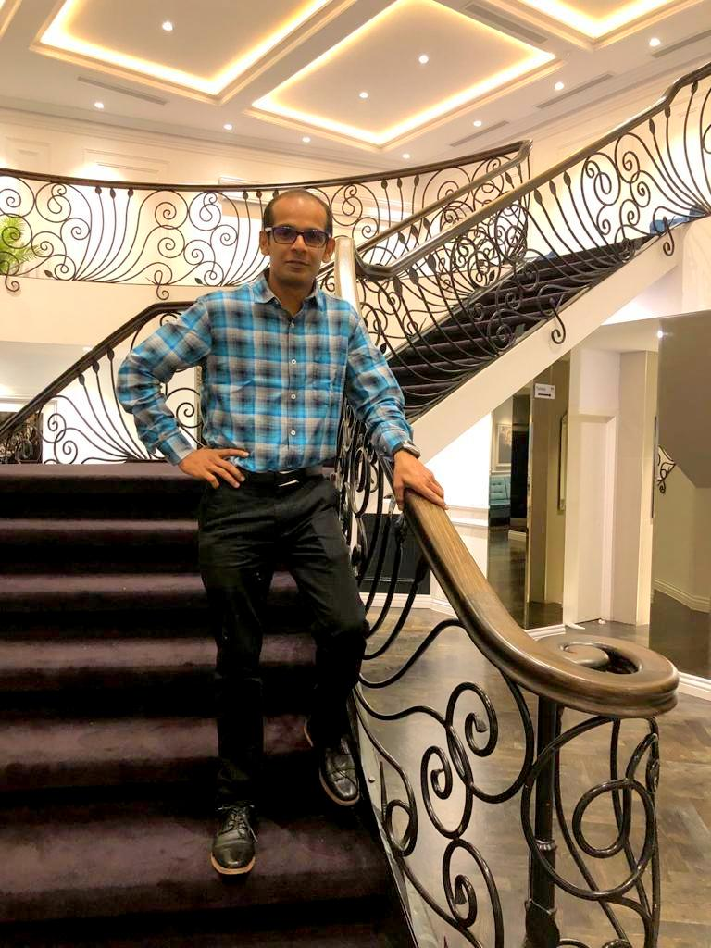***Rajaneesh Sankaran Nair Sukumarai Amma***

Raj was born and raised in India and moved to Australia in 2012. He now lives in Dandenong, in the south-east part of Melbourne. His hobbies are travelling, pencil drawing, playing chess, listening to music and cruising. His best sailing was an amazing 14 nights cruise with Princess Majestic ship to Sydney from Auckland, New Zealand. Rajaneesh holds a diploma in Mechanical Engineering and is a certified Computer Numerical Control (CNC) programmer. He started his career with Suzuki Motors as a CNC metal cutting Machine Operator in Gurgaon, India. Presently he works with Australia’s most reputable recreation vehicle manufacturer - Jayco Caravans as a Team Leader. It is his dream to become an IT professional, and knowing his passion, his lovely wife Ayswaria suggested that he do an undergraduate course in IT. He knows that this will be a milestone in his life.

**Test Results**

As part of our first assignment in Introduction to IT, we each undertook three online personality tests, with the aim of helping us to identify our behaviour when forming and interacting in a team. We all participated in a Myers-Briggs Type Test at <https://www.16personalities.com/>; a Learning Type Test at [emtrain.eu/learning-styles](http://www.emtrain.eu/learning-styles/) and a third test of our choosing. Benjamin and Jordan chose to do a Learning Styles Test at <http://www.emtrain.eu/learning-styles/>, Jacob and Rajaneesh chose to do a Leadership Test at <https://eml.usc.edu/leadership-style-quiz>; Murray took a Creativity Test at [testmycreativity.com](http://www.testmycreativity.com/); and Sneha took a Human metrics Jung Typology Testat <http://www.humanmetrics.com/cgi-win/jtypes2.asp> The results of these tests are tabled below:

|  |  |  |  |  |  |  |
| --- | --- | --- | --- | --- | --- | --- |
| TEST TYPE: | Myers-Briggs Test (16 Personalities) | Learning Styles Test | The Big Five Personality Test | Leadership Test Results | Creativity Test | *Human metrics Jung Typology Test* |
| Ben | INFP  ISFP  INFJ | Auditory: 20%  Visual: 40%  Tactile: 40% |  |  |  |  |
| Jordan | INFP-T– Introverted Intuitive Feeling Perceiving and Turbulent | Pragmatic: 42%  Theorist: 25%  Activist: 11%  Reflector: 11% | Extroversion: 67%   Emotional Stability: 39%  Agreeableness: 51%  Conscientiousness: 31%  Intellect/Imagination: 46% |  |  |  |
| Jake | INFP-T– Introverted Intuitive Feeling Perceiving and Turbulent | Pragmatist style 32.8%  Theorist style 24.8%  Reflector style 24.8%  Activist style 17.6% |  | Contrarian Leader |  |  |
| Murray | ISFP-T | Auditory: 35%  Visual: 40%  Tactile: 25% |  |  | 67.34 | Openness: 62.5%  Conscientiousness: 48%  Extraversion: 48%  Agreeableness: 79%  Neuroticism: 65% |
| Sneha | ***ENFJ-A***  Extraverted:  85%  Intuitive:  67%  Feeling:  89%  Judging:  85%  Assertive:  86% |  | Openness: 85%  Conscientiousness: 92%  Extraversion: 90%  Agreeableness: 98%  Neuroticism: 0% |  |  | ***ENFJ***  Extravert:  69%  Intuitive:  47%  Feeling:  28%  Judging:  56% |
| Raj | ENFJ – The Protagonist | Reflector style: 23.3%  Theorist Style: 29.4%  Pragmatist style: 29.4%  Activist style: 17.9% |  | Metamodern Leader |  |  |

Based on the data provided by these online tests, we are again shown to be quite a varied group. We have a range of different personality types, learning styles, and other personality characteristics. This combined with our varied life and professional experience should give us a good range of skills to work with, and hopefully the strengths of some members can counter the weaknesses of others. At the same time, it seems as though we have some strong similarities and relatability. While we have a mix of introverted and extroverted personalities, we all share the ‘feeling’ trait so we can relate to each other in that we tend to think with and follow our heart more than people who are primary ‘thinking’ orientated. People with the ‘feeling’ trait also tend to be more empathetic, caring and compassionate, which would give us a strong advantage in teamwork as we will be more inclined to help each other out and be more understanding of each other’s shortcomings and in situations beyond our control (Nature: Thinking vs. Feeling | 16Personalities, 2020).

We have each reflected below on how we believe our individual test results might influence our behaviour in a team:

Ben does not believe that these results would affect how he would go about working in a team, as a team is a collective of people that work off one another’s strengths and weaknesses. However, this doesn’t always work out and based on the results of the Myers-Briggs test, he is shown to be someone that is likely to be an empathetic team member that will put a foot forward to aid his fellow group members. Paired with the Big Five test rating him highly on Agreeableness, he feels that his contributing features to the team seem to match well with keeping a team cohesively together.

Jordan considers that these tests have shown that although he strives to be open, honest and involved in a group work situation, there is a big part of him that will want to shy away and be that introvert that he knows he can be sometimes. When working in a team he usually is just extroverted enough to end up in a leadership position.

Jacob feels that the Myers-Briggs test results show him to be shy and introverted on the outside, but vibrant and passionate on the inside. He will do his best to maintain harmony in the group but will need to make special efforts to assert himself and put his ideas forward confidently. As his dominant learning style is pragmatic, he thinks he may be at his best and most useful to the team when working on actual content rather than in the planning and brainstorming phases. As a contrarian leader, he feels that his non-binary way of thinking may help the group to find new solutions to problems, but at the same time, he will also tend to shy away from and defer decision making.

The Myers-Briggs test results do not surprise Murray as he is quite an introverted person. Within a team, he believes that he is usually the quieter one and his input it usually more thought out and with meaning. He is also someone that likes to observe and investigate all the facts before he makes any decisions or take any actions. As his dominant learning styles are shown to be auditory and visual, he agrees that he has always found that he learns best with visual cues like video or text. He finds that he is creative when it comes to problem solving (He basically does this for a living), and while he is glad that the creativity test shows him to be above average, he admits that he thought it would be higher. He feels like he would be good at thinking through problems and finding a solution that works, even if it is not the most straight forward and obvious.

According to the results, Sneha understands that she has extraverted, intuitive, feeling and judging personality traits. These results are a testament to her personality type as being a person who is warm, forthright, and known to have strong ideological views and values. With these traits in mind, when placed in a team environment, she generally takes on the role of the collaborator and likes to inspire other team members by working together to implement plans for progress. She works from supportive relationships as her foundation; she is adept in understanding the needs and priorities of others and is talented at building consensus. Also, she is a visual learner and considers herself to be visually creative. Her strengths lie in drawing, building and creating. She engages in learning by using colours and diagrams and learns best from reading, videos, and presentations.

Raj describes how the Myers-Briggs test results are the same as his boss’s opinion of him, that is, he is kind and generous and cares about helping and connecting with others. He tries his best to understand the strengths and weaknesses of himself and others. He feels so proud and satisfied whenever he sees those seven ‘Best employees of the year’ in his room. His employers gave him those awards for his leadership qualities, creating a harmonious work environment and relationships with team members, motivating and helping others. He is always inspired by results and criticism. He will consider these test results seriously to improve his character, attitude, communication, leadership and professional skills.

Ideal Jobs

As part of our individual tasks in assignment 1, we each chose an advertisement for a position that we would consider to be our ideal job. Our ideal jobs our listed below along with a description of each, so that we may analyze and compare them for common elements and differences. We have also included a brief plan of steps to take in order to become qualified for these positions.

**Head of IT – Jordan**

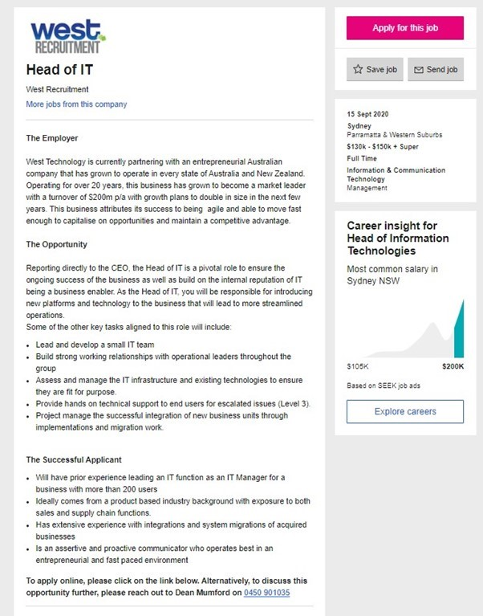

Jordan has chosen Head of IT at West Technology in Sydney.  
This is a leadership role reporting directly to the company CEO and involves not only maintaining the IT infrastructure of the company but also communicating with other areas of the business and of course leading the rest of the IT department. He has plenty of experience in Leadership and Management and using those skills in an IT setting would allow for more job options and in this case quite a large expected rate of pay.

This is a Management position and Jordan has worked in Management for several years so he believes that his prior experience would be beneficial. He also has several Management Certificates.

Jordan believes that his first step towards the skills and requirements for this position would be to successfully complete the Bachelor of IT, as well as continue his work in management to build as many skills as he can. Next, he would want to gain experience in the IT industry and work towards an IT Management position to gain the IT Management experience required, and specifically experience in system migration and integration.

**Frontend Software Engineer – Jake**

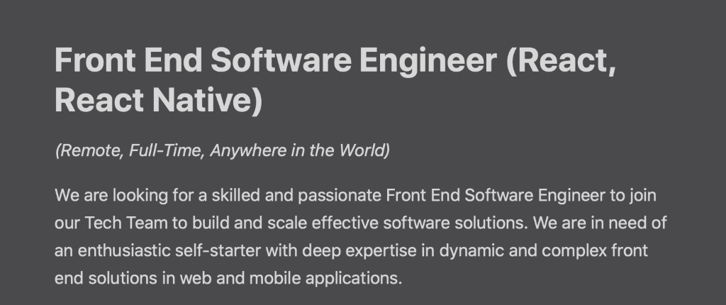

This is a remote position is for an experienced front end software engineer. This role would involve liaising with the organisation’s creative and business analysis team to design and build software for the client with the goal of streamlining and automating their processes.

Front end appeals to Jake as it involves working with products that he considers to be tangible (such as an app or a website) and he likes to be able to visually see or interact with what he is working on. Jake is an organised person who likes to tick boxes and he believes that he would take great satisfaction in taking a brief all the way to a final and optimised product.

Jake believes that his best course of action to qualify for this role is to complete the bachelor of IT and utilise any opportunities to practice with different tools and programming languages and try to keep up with industry trends. He also believes it to be vital that to start building a portfolio of any design or programming work that he does and probably most importantly would be to get an entry level job in IT where he can hone his skills and gain some real industry experience with which to use as a stepping stone to his ideal job.

**Customer Solutions Architect – Murray**

<https://sye.tbe.taleo.net/sye02/ats/careers/v2/viewRequisition?org=MACQTELE&cws=37&rid=1513>

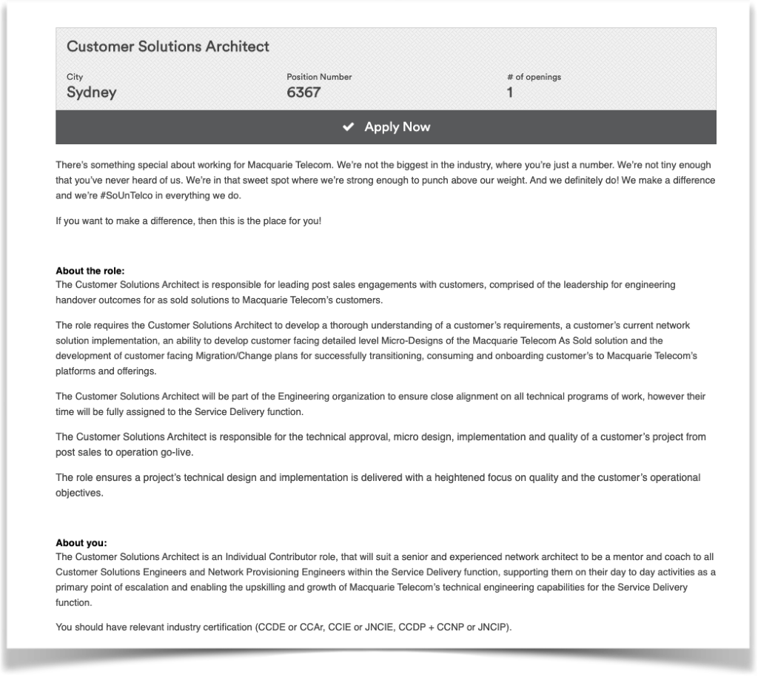

In the simplest of terms, a Customer Solutions Architect takes a client’s desires and needs for their network and makes it into a reality. They are depended upon by all facets of a business for their technical expertise and ability to make customers happy and make money for a business. Murray likes the role as it involves problem solving and vast technical knowledge. It also requires some customer service which he is already competent at, without it being necessary for success in the role.

CSAs must have a proven knowledge of network architecture and current products. They must have certificates to show this ability such as CCNA (switching and networking) and CCNP, along with other vendor certificates that aren’t CISCO based, such as Juniper. You will need some years of professional experience in a Similar role as there is a lot expected of you from various stakeholders in the business. He currently does not have any of the certificates, although before he started his current role, he was studying for his CCNA. Murray thinks the first step will be to complete the CCNA, then move on to more technical CISCO certs. At the same time, he would also like to complete certs from AWS, Google and Microsoft for their cloud products. In the long run, Murray would like to be a CSA specialising in cloud.

**Test Manager – Sneha**

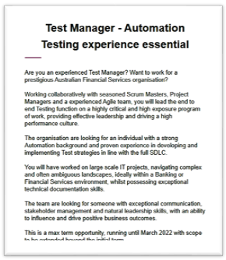<https://www.seek.com.au/job/> 50479447 (SEEK, 2020).

Sneha’s ideal job is a Testing Manager. Becoming a Testing Manager is appealing to her as it’s more than just about coding, it’s a role which will allow her to thrive and make a difference to an organisation through quality control and being able to examine/critique other people’s work.

**The Test Manager is responsible for:**

* Motivating and leading the Testing Team to the success of project
* Specifying the scope of testing within the context of each release / delivery
* Deploying and managing resources for testing
* Utilising suitable test measurements and metrics for the product and the Testing Team
* Planning, deploying and managing the testing effort for any given engagement.

(<https://www.guru99.com/introduction-to-test-management-for-curious-manager.html>, 2020)

**A Testing Manager must have the following skills/experience:**

* Strong communication skills- written and verbal
* Demonstrate Strong leadership qualities
* Ability to influence and drive positivity within a team
* Ability to deliver high-quality results to their clients

Sneha’s plans to obtain such a position has been a plan in the making for some time now. She has already completed a Diploma in Project Management, and an Advanced Diploma of Business Management. She will need to complete her degree in Information Technology as generally this is a requirement for most companies. She also plans to obtain some professional Project Management Accreditations like PRINCE2 and Agile. Ultimately, she would like to gain required skill set for a Testing Manager’s role and process further within the Department of Premier and Cabinet (VIC).

**Artificial Intelligence Specialist – Raj**

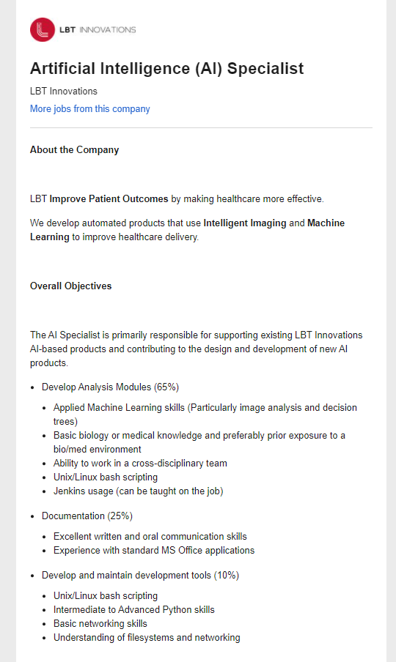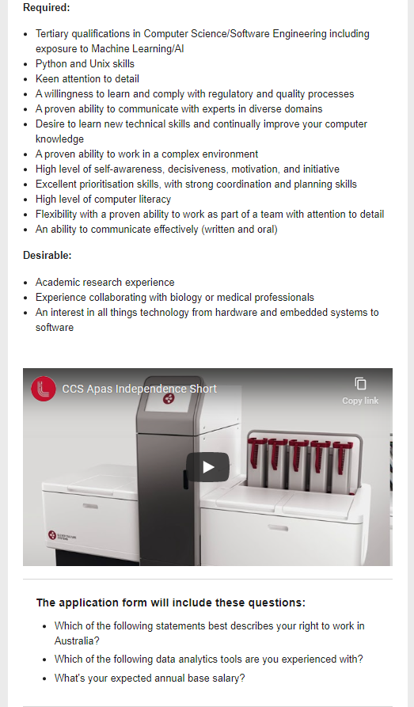

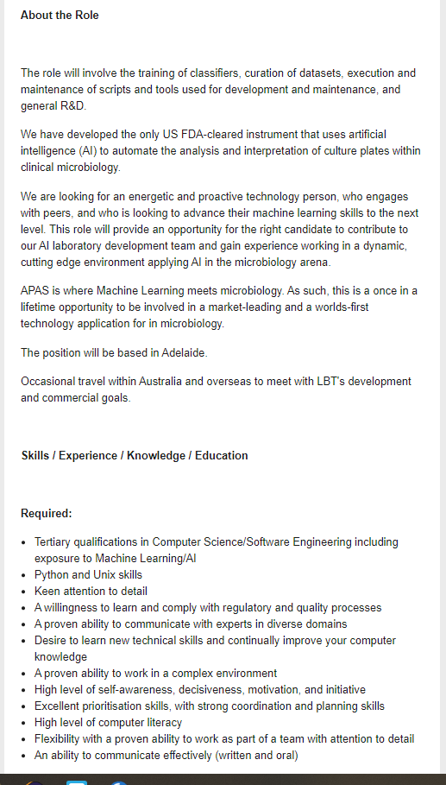Raj has always wanted to work with software companies in the healthcare industry. He knows that artificial intelligence will play a serious role in the future, especially in the healthcare industry. LBT INNOVATION is one of the famous AI companies for developing advanced technology solutions for the healthcare industry. They have a great reputation in clinical laboratories for developing AI based solutions. I come from a strong and solid mechanical knowledge and experience. So, I am hoping that I am one of the promising candidates for them when I achieve excellent knowledge and experience from other companies.

Raj’s plan is to complete his undergraduate course successfully (Bachelor of IT) before he will have to gain a strong knowledge and experience in Machine learning artificial intelligence. He needs to study an additional course in Python and Unix along with Bachelor of IT. He needs to have excellent experience with healthcare data and solutions, so that he will have experience in R&D using AI tools and techniques. He plans to gain internship experience in any of the AI companies to have excellent experience in source controls, Machine learning, Deep learning and advanced technologies in AI. He will also discuss with his RMIT tutors for guidance to meet the requirements.

**Data Science Engineer – Ben**

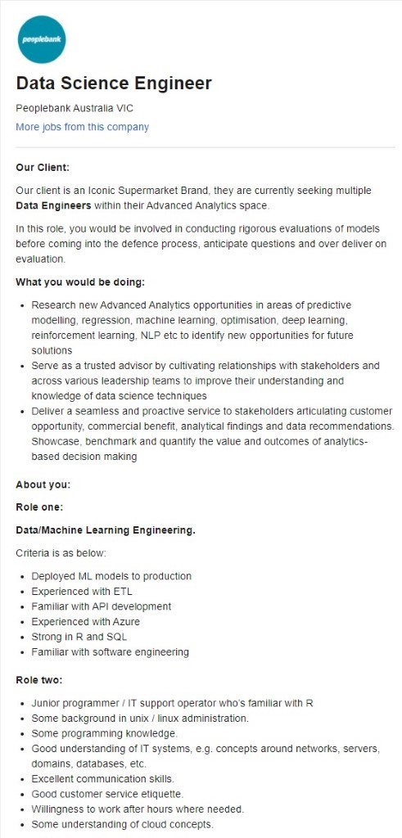

Ben decided to have a look at a job that was slightly different to standard career paths this course would usually lead to and was rather intrigued. Using experience brought about from an interest in the IT field, a job as a data scientist requires the use of practical code knowledge, statistical awareness and using these to assist a business with trend and scope identification.

This appears to be how it sits within the scope of this job as well, along with requiring one to be able to prototype tests based on returned results, providing optimal solutions and usage of one’s abilities to assist the business forecast future business transitions and changes for the inevitable benefit of the company

If he were to work towards a role in the Data Science field, Ben would need to develop and get a better understanding behind coding as well as develop an understanding of data from a more statistical point of view. As someone who has always had a keen interest in puzzles, complex challenges and the like, this type of role has certainly caught his intrigue.

**To summarise some key elements and highlight some similarities and differences between our ideal jobs, we have created the following table:**

|  |  |  |  |  |  |  |
| --- | --- | --- | --- | --- | --- | --- |
| Job Elements | Management  /Leadership Role | Technical Role | Communication Skills Vital | Remote Position | Customer Service | Req. Further Training/  Experience |
| Ben |  | ✓ | ✓ |  |  | ✓ |
| Jake |  | ✓ | ✓ | ✓ |  | ✓ |
| Jordan | ✓ | ✓ | ✓ |  |  | ✓ |
| Murray |  | ✓ | ✓ |  | ✓ | ✓ |
| Raj |  | ✓ | ✓ |  |  | ✓ |
| Sneha | ✓ | ✓ | ✓ |  | ✓ | ✓ |

These key elements have been taken from the individual members’ own descriptions and interpretations of their advertisements as well as the advertisements themselves. This means that they may not necessarily include all the job elements as described by the ads, but may be indicative of the elements given most emphasis by the employer or the elements that are most important to each member in their ideal position.

It may not be surprising from a group of IT students to note that we have all chosen roles that require a certain level of technical expertise. While there are varying levels of technical expertise required in these roles, we have all identified that we will require further technical training or work experience in addition to the bachelor of IT to qualify for these roles.

It may be more surprising to note that each job description demands a high level of communication skills. Whether it be liaising with different internal departments, colleagues, superiors, juniors, clients or other stakeholders, each role requires a lot more communication skills than the stereotypical introverted IT worker of the movies has. In fact, it seems that the introverted among us must learn to step out of our shells in order to be successful in this industry.

A few differences are apparent from this table too, namely that Jordan and Sneha have chosen managerial/leadership roles. This is not surprising given their natural leadership skills as demonstrated by their career experience and personality test results.

While a lot of these positions may be performed remotely and may include elements of remote work, Jake was the only group member to choose a specifically remote position. Murray and Sneha were the only members to choose positions with a heavy focus on customer service.

In addition to the information gathered from the table above, we can also identify many trends in the specific plans to obtain these jobs as identified by the individuals. Some common themes include, continuing the Bachelor of IT to completion; learning specific tools, coding languages and techniques; further training and education including specific technical certificates and managerial certificates; and gaining industry experience through either relevant current employment, entry level IT jobs or internships.

Industry Data

The job titles for our ideal jobs as discussed in the ‘Ideal Jobs’ section, as well as how these rank in terms of demand from employers according [Burning Glass](https://www.burning-glass.com) and [LinkedIn](https://www.linkedin.com) are described below:

* **Data Science Engineer – Ben**

Data science has had a boom in demand from employers over the past 18-24 months which would explain why it does not have a representation in the Burning Glass Data. According to LinkedIn there are currently 376 Data Science rolls being offered in Australia. Based off the Burning Data rankings it would have been ranked 16th.

* **Head of it - Jordan**

A search on LinkedIn found that there were currently 44 listings for Head of IT (or similar) roles available in Australia. It is not on the list supplied by Burning Glass.

* **Frontend Software Engineer - Jake**

This role is the 6th most in demand role from employers according to the data provided by Burning Glass. According to LinkedIn there is currently 425 advertised positions for this role.

* **Customer Solutions Architect - Murray**

Burning Data ranks this as the number 1 most in demand from employers. According to LinkedIn there is currently 768 listed roles being advertised. The role can vary greatly in terms of specialisation but generally revolves around network design and cloud.

* **Test Manager - Sneha**

Test Manager is not on the list of desirable jobs provided by Burning Glass. However, according to LinkedIn there is currently 354 positions advertised for a Test Manager role. This would have made it the 17th ranked role in the Burning Glass data.

* **Artificial Intelligence Specialist - Raj**

This role again does not get listed in the burning Glass data. However, LinkedIn shows that there are currently 819 roles advertised in Australia. The role is quite broad so there are more specialised roles, but it is still clearly a much sought out specialisation amongst prospective employers.

Our group skillset is made up of the skills that we have identified as being required for our ideal jobs. These skills have been listed below and divided into two groups - general skills and IT-specific skills. The Ranking in terms of demand from employers as described by Burning Glass are displayed in the brackets next to the listings (1 being highest in demand, 2 being second highest in demand etc.). The top skill requirements for the groups Ideal Jobs that are not listed in the Burning Glass data are displayed with red numbers.

**General SKILLS**

* Communication Skills (1)
* Problem Solving (2)
* Organisational Skills (3)
* Teamwork/Collaboration (5)
* Troubleshooting (6)
* Planning (7)
* Detail-Orientated (8)
* Research (10)
* Leadership (11)
* Quality Assurance and Control (14)
* Analytical Skills (17)
* Team Building (18)
* Management (19)
* Decision Making (25)

**IT SPECIFIC SKILLS**

* SQL (1)
* JavaScript (2)
* JAVA (3)
* Microsoft Windows (4)
* Project Management (5)
* Business Management (7)
* Business Relationships (8)
* Google and Amazon Cloud services certifications (1)
* Business Analysis (9)
* Technical Support (11)
* Microsoft C# (12)
* Linux (13)
* Software Engineer (15)
* .NET Programming (16)
* Microsoft Office (18)
* Systems Engineering (24)
* SAS and R. (1)
* Python (22)
* Scrum (23)

The three highest ranked in demand IT-specific skills as listed by Burning Glass that are not included in our group’s skillset are:

* SAP (6)
* Graphic Design (10)
* Customer Service (14)

The three highest ranked in demand general skills as listed by Burning Glass that are not included in our skillset are:

* Creativity (9)
* Time Management (12)
* Mentoring (13)

Since investigating our ideal jobs and looking at the data presented by Burning Glass, we have had an opportunity to re-evaluate our opinions on our ideal jobs and our individual reflections on this are outlined below:

**Murray -**

No, I have not changed my decision. According to the Burning Glass data Solutions Architect is the number one most sought after roll and this is backed up by the current Australian listings on LinkedIn. I already had an understanding on what was required in terms of general and IT specific skills required so this has not changed my decision.

**Jake -**

After looking at the Burning Glass Data, my ideal job position of Frontend Software Engineer remains unchanged. It is currently described as the sixth most in demand role and I believe that the job opportunities will continue to grow, so I am quite happy to invest time and effort into further developing the required skills for this position.

**Jordan -**

The Burning Glass Data shows that My choice of Ideal job is not the most in demand, however I do not believe that is reason enough not pursue. It just means I need to prove myself to be the best choice for the job.

**Sneha -**

As outlined in the Burning Glass data a testing management role is not the most preferred role. However, given my exposure already in the testing arena and as shown from my behavioural assessment that I have leadership/ mentoring personality traits, I would still be inclined to grow within this area. Regardless, I am willing to apply my knowledge and skills to grow. Also, my interest in testing does not restrict me from gaining exposure and experience in other areas like Cyber Security etc. which I can always do simultaneously.

**Raj -**

According to burning Glass data, Artificial Intelligence Specialist does not have many opportunities. However, LinkedIn shows that there are currently 819 roles advertised in Australia. So, I stick with my plan to chase my dream job. I know there are endless opportunities for in artificial intelligence technology and I will work hard to meet the requirement for this role.

**Ben -**

Following the Burning Glass data, the Data Science Engineer is a relatively in demand job, with it ranking 16th on the charts, however with its boom in the industry over the last couple of years it is a job that will have continual growth into the future. With that being the case, I do believe that striving for this type of job as a goal would place me in good stead.

IT Work

**Interview Transcript**

**LIAM NESTEROFF - SENIOR TECHNICAL CONSULTANT**

Recording Available [Here.](https://jake-patrick.github.io/IIT-Assignment-2-Group-Work-Repository/interview.mp3)

“Please tell us about your IT work. What exactly do you do?”

L N - “I am a Senior Technical Consultant for a company called Servian, who deal with Tier 1 and 2 organisations with Australia and other regions. My primary focus lately has been cloud architecture or cloud native computing, things like Kubernetes or containerised applications with a pretty strong security focus. Basically helping enable enterprises to get the most out of their compute powers.”

“Tell us a bit more about the industry that you work in?”

L N - “ As a consultant I am not locked into a certain industry, I work across financial, airlines, media, telecom. Basically anyone who is willing to pay!”

“What was the Education pathway that led you to the role you currently have?”

L N - “I started to study Computer Science at the University of Sydney, whilst also working part time doing system administration and IT support for a different organisation than the one I am currently working at. About halfway through my degree they offered me a full time position which I accepted. Then uni became something of the past and I never finished my degree.”

M N - “It sounds like you were still able to get somewhere in your career, is that with certifications?”

LN - “Yea so professionally I have got about 15 industry certifications across all of the cloud providers, VMware, Kubernetes even Oracle for some reason.”

M N - “Do you have to do the classic CISCO ones like CCNA?”

L N - “Not quite, I deal with things at a sort of more higher level. More general architectures rather than that low level interaction with the networking gear.”

“What was your professional pathway that led you to your current role?”

L N - “So after the first organisation where I was the systems administrator, I was there for almost 5 years, then I took a position in my current organisation in their managed services division supporting a customer who was then running VMware. Then taking them on the journey from VMware to running on Amazon Web Services. At the time cloud wasn’t really a big thing, I mean it was a big thing but not many people were doing that sort of thing at this level within Australia, or the region at least. So I was given quite a lot of opportunity through large organisations and large projects to be doing a lot of cloud work early on in my career which really sort of gave me experience that nobody else really in the industry had or still has at this point. So that was able to project me out of managed services into consulting, pre-sales and architecture.

M N - “And when you say managed services, do you want to explain what that is?”

L N - Yea so managed services within our company it was IT support as a service with the ability to draw upon the greater consulting pool that my organisation has. So your basic level 1,2,3 IT support but also be able to have these larger projects and engagements off the back of that managed services. So uplifting from VMware to AWS for instance would be a larger project that is out of the scope of a normal MSP (Managed Services Provider), which is something we are able to do.”

“What other kind of work do you do in your role?”

L N - “So I do pre-sales work, developing proof of concepts and MVPs to help us try and win work with our customers. I do sometimes the delivery of said work, actually deploying and working with teams there. I run a lot of workshops whether that is training or just discovery workshops with stakeholders to understand what their requirements are. Or training the technical engineers to be able to handle the environments once we built and deployed it for them. I am also a certified Google trainer so I am able to run technical training for external users, people who are signing up to users which is something my organisation does, running courses for the general public.”

M N - “So its not just really IT but you still have bits of other industries like sales and education rolled into your roll.”

L N - “Yea well it is IT but it is not hands on IT work.

M N - “Yea so you’re not just sitting there on a PC hammering away 24/7, you’re actually sometimes have to be out there on a person to person level.”

L N - “Yea that’s exactly right, I would actually be doing the actual delivery work like 25-30% of the time.”

“Who are the different people you interact with in your day to day work?”

L N - “So from a pre-sales or an engagements perspective I deal with both technical and non-technical stakeholders. So non technical being your CTOs, Division and product owners or platform owners. So for instance if I was going in to try and deploy Google Cloud or Amazon Web Services I would be talking to the cloud or platform owner to find out their requirements, function and non-function requirements from their perspective. As well as talking to the technical stakeholders, your network engineers for IP site arranges, firewall ruling and interconnect questions. Your security engineers for security controls and policies for what we need to enforce within our design. Developers for how they actually want to interact and work with the systems. So talking to all the different stakeholders, all the different people, that have a buy in into this platform that we will be deploying so we can get the best solution design and deployed for them and actually get it designed and deployed within their constructs and constraints.

“What is our interactions with other IT professionals? You kind of touched on it before.”

L N - “ So from a pre-sales perspective talking about designing solution. But also from a workshop perspective I would be talking to the actual engineers who will be running the systems or solutions that we are developing after we leave. So we might be taking over as a managed services client, but if we are not and they are wanting to look after it themselves, oftentimes there is a degree of up-skilling required for their internal IT services and teams. So I will be running workshops and training them up on how they can work with this.”

“What aspects of your work do you spend most time on?”

L N - “So it is a bit split at the moment. So if we are talking about pre-sales, delivery and just sort of general training, workshop and up-skilling within my organisation and clients, it is more like probably evenly split across all of them. The thing that is probably right now taking up most of my time is pre-sales but a month ago it was delivery, so it shifts and changes any given week,”

“Just touching back on what you were talking about before, are you mostly interacting with IT professionals or something is it non IT people?”

L N - “Yea so sometimes it would be non IT people depending on who has a stake in what we are doing. So for the larger organisations, or larger projects rather, I get put into meetings with more senior C level people, CIOs and sometimes CEOs of these companies because it is a significant investment on their part to engage us and have this project. Often the return in investment would be huge but getting this involved, getting the right solution and partner, it is a huge investment from their perspective. So often we get this business side people involved in these meetings,”

M N - “I guess its the challenge of, not dumb it down, but work it in a more digestible way.”

L N -“Yea exactly right, yep.”

“What aspects of your work do you find the most challenging?”

L N - “So when I am trying to design a solution, like when I am trying to architect a cloud platform architecture for a customer, like I mentioned before we need to make sure network ranges are concise and we need to make sure we have the right site arrangers applied as well as security as well as features and functionality for developers as well as data structures enabled for data analysts. Its making sure all these things work, and with these large organisations each of these components have different teams and different silos of knowledge and requirements and needs and wants and for the larger organisations often times they are not communicating with each other. So you will get a security requirement that contradicts the networking or developer requirement and they are both saying ‘this needs to happen’ or ‘this can’t be happening’ and they contradict each other. Often times the solution is just getting them to talk to each other and educating them and getting them to understand the solution that we are putting forward and making them compromise but it is sometimes very difficult to design a solution that makes everyone happy. Some of time it is not possible so it is just making sure that we have that compromise.”

M N - “Yea so it sounds like it goes back to what we were saying before were it is not just all IT sometimes you have to be a mediator or an organiser.”

L N - “Yep.”

“How has COVID impacted your role and the industry you work in?”

L N - “So me personally, COVID has not made too much of a difference. When it hit and for 6 months after it started, I continued to work for the client I was working with 6 months before it started. The only difference for me personally is that I was commuting down to Melbourne every week and in February that stopped. Even when I was commuting, I was only commuting for 2-3 days and the other days I was just working from home so after the commuting stopped, I just continued working from home full time. For me it doesn’t make any difference at all apart from less early mornings to the airport. For my organisation, we were quite lucky, and it didn’t impact us too much at all. Like probably most business we had a hiring freeze, but we did not fire anyone or let anyone go. As far as the industry goes, as a consultancy we are generally an unnecessary expense for businesses, well not unnecessary, but it is usually for a project that is going to enhance something. It is not trying to put out a fire, it’s trying to build a new system or application or enhance the way things are happening, which should still give you a return on investment.”

M N - “But it’s still an investment.”

L N -“But it’s still an investment, yea business weren’t investing. Some of our customers cut back on the contract sizes we were dealing, some deals that were almost about to be signed were pulled away and finding work was a lot more difficult. A lot of large organisations I know of had a consulting and contractor freeze, so they weren’t actually allowed to engage people like our organisation because their directive from the top of their organisation that until there is more certainty in the industry or global economy we will just do BAU, business as usual.”

“So what does your next role look like”

L N - “So what I am currently working towards is, so I am currently a Senior Consultant, I am looking over the next few months within the same organisation to transition in a Managing Consultant role which is a bit more hands off on delivery and a but more hands on with a whole array of different clients and just having an overview of them and supporting across multiple engagements, multiple customers, multiple teams and multiple consultants from my organisation and supporting them and helping them to deliver the products.”

M N - “So in your opinion IT has a lot of opportunity in terms of an industry in terms of growth? You see a lot of opportunity in it?”

L N - “For sure, everyday there is a new cool thing and every now and then a whole industry spawns off it. When I first started IT VMware, Virtual Machines, was the greatest thing that has ever happened, and it was the future. That was never going to die away and I got certified in VMware and was focusing everything I wanted on VMware. Then cloud happened and now VMware is struggling to stay relevant basically at this point in time. Cloud has spawned so many industries itself, from the elastic computer, machine learning, data science, artificial intelligence and cloud native computing. All these things that used to be only available to your large organisations that are able to afford an entire data centre. It has now been democratised so that small to medium business are able to have a machine learning algorithm, do data processing. So the amount of work in IT and Consultancy across the board has just grown exponentially over the past 5-10 years.”

“Finally, can you share one example from the work that you do that best captures the essence of the IT industry?”

L N - “Yea I think getting these different teams to try and agree and talk to each other. I think the fact that you have to do that encapsulates the IT industry. There are all these teams and groups  that are locked in an engrained in their own ways, policies, procedures, toolsets. Trying to get them to integrate and work with other teams can be quite difficult. It is finding that compromise that is quite important.”

M N “And on the positive side, like you were saying before, it is such an elastic industry and every day there is something new.”

L N - “Yea for sure, My career starting at VMware gone to cloud gone to cloud native opportunities, things like Kubernetes and Containerised workloads and micro services. Then going to architecture and doing security reviews and training. It has been all over the place and this is just where new cool technologies have spawned and created entire industries based of a single system, a single application, like Kubernetes.”

M N - “You have also been able to travel the world for your work as well.”

L N - “Yea I do conference around the place, I work with clients in Japan, Singapore, New Zealand. I have been to conferences in Copenhagen and America. It has been an exciting journey.”

IT Technologies

We as a group are fascinated by the developments happening in the IT world and are excited by what the future may hold for our industry. Many historic technological developments have changed the way the world works today. We have lived through the initiation of personal computing and internet. We now live in the ‘smart’ era, with smart phones, smart tv’s and smart watches and satellite technology. Our lives are dominated by social media, cloud computing and online privacy and data concerns. We live in the infancy of Artificial Intelligence. Here we have taken the time to examine four growing areas of IT in further detail: Cloud, Service and Server-Based Computing; Cyber Security; Robotics; and Machine Learning. We have discussed what these technologies do, what their likely impact is and how they will affect us personally and as a society.

***Cloud, Service and Server-Based Computing***

1. What does it do?

Cloud computing when boiled down to its basics is the use of technology to create an environment where information and data can be stored in a central location that can then be accessed from anywhere in the world. Using the internet, resources such as mass data storage, servers, databases and software become readily available for usage across the globe.

This in turn effectively negates the requirement for local storage solutions such as standard local hard-drives and server systems, as cloud solutions allow for greater flexibility with your data. Whether it be due to requiring the ability to access data remotely, have an increased level of security or just a safe storage location for ones data with a high level of redundancy, cloud based data servers and services tend to trump that of local storage solutions in every way.

In today’s environment, the use of cloud computing and solutions are highly populated and sought after by big businesses and individuals alike. Businesses in particular benefit from Cloud Computing well beyond what was envisioned only 10 to 15 years ago, when systems such as Dropbox and AWS were in their infancy. An example of this is the sheer cost savings that businesses can achieve when working off entirely cloud-based server systems. For many years’ past, large-scale businesses would have to set aside a physical space where they would have to then fund and build large data storage facilities. After which this space would need to be maintained and managed on site, with full scalability factor being integrated pre-build to accommodate further company growth. This is especially time consuming, and expensive on the business.

This exact issue is made even more apparent when you look at this same idea however this time, from the perspective of a small business looking at growing. How much storage would a company need in order to grow at a scalable rate, without either running into issues created by taking off and suddenly running into a lack of storage space, or funding problems due to overcompensation. In both instances, if not balanced well initially, this could effectively make or break a business.

This is where systems such as the hugely successful Amazon AWS come into effect. AWS offer cloud-based storage services for businesses for companies of any size. They offer all the necessary tools required to create a self-contained storage system on the web, charge the business for what storage and functions they use, as well as seamlessly allowing existing businesses to migrate data directly from local storage facilities onto the AWS systems. And this is just one large example of cloud-based services.

More simple systems such as Dropbox, Google Drive and OneDrive are equally as prevalent in our current everyday lives. Over the last 10 years these systems have really begun to encapsulate the world, whether it be through the automatic use of Google Photos synchronisation on Android phones backing up your photos to a linked Google Account, or the use of DropBox to share music files between friends remotely. These are all cloud-based systems that are actively used by individuals and businesses alike on a day to day basis. And it is all in the name of convenience and data security. Into the coming years Cloud Systems are going to continue to revolutionise how we interpret data, from a tangible source that is kept close to one’s fingertips, to a piece of information that is freely available for the individual to access wherever they want to in the world.

1. What is the likely impact?

The most immediate impact that cloud server/systems have had on the IT industry is the impact that had on the requirement for local data servers. Whether it is for a large-scale business requiring high levels of security, or small independents requiring minimal data storage space to operate. Physical on-site servers and storage just cannot compete with the cost efficiencies that Cloud Services offer. Comparing electrical costs, initial setup costs of storage bases and general maintenance costs for a local storage facility, or the ability to pay for amount of storage used, as well as the required service level. For any business, this really is becoming a question of when, rather than if.

Change in this space is happening in front of our eyes as well. The use of USB’s for data transferring and sharing has been quickly replaced with file sharing services available online. Physical landlines and even VOIP based systems are being replaced with AWS phone systems, Microsoft Teams, Zoom and the like. Systems that are hosted and managed entirely cloud-based systems for use globally by anyone. All that is required is an internet connection and a phone or laptop.

From a business perspective, these changes are immense. But even to the individual, the effects of cloud systems is evident in day-to-day life. More people are online than ever before, and the requirement to always be available at the press of a button. This is the same for humans and data alike. Always available, from anywhere.

In this sentiment, the rise of cloud-based systems has created an entirely new range of job types to the market. Cloud engineers are required to manage the businesses cloud-based servers and systems. Whether it is in migrating data from physical data centres to the cloud, or even just management over the cloud system in use, there is always going to be the need for this to be maintained from a business perspective. This creates jobs for network engineers, where they might’ve otherwise lost work due to the redundancy created by the removal of local server systems.

1. How will this affect you?

Imagine this. You accidently drop your phone while out walking, smashing it, and ruining it entirely. What happens to all the data kept on it? Is it all lost, photos, texts, and documents kept on it all gone in an instant? This is not even remotely the case and has not been a problem for a couple of years now.

These are the fears of yesteryear. For the most part, all phones that are purchased are linked directly to some form of association account before you even get into it. Whether it is a Google account, Apple account or other associated account, this has become a requirement. Then while actively being used, most automatic backups are always running, moving locally taken photos, messages and general data off the phone and onto a cloud-hosted storage system that only those with the account details can access.

Data loss is minimal, if it exists at all, and data recovery is easier than ever. No more loss of precious photos and memories and no more lost homework for school assignments due to hardware failures. For individuals, cloud hosting has become integrated into our everyday lives, most of it slipping in almost unnoticed but always being used for the better of everyone. Whether it is for easier access to emails, online banking and data extraction from anywhere in the world, to managing and operating a business from home, we have allowed for cloud computing to establish itself into our everyday lives. Its cost effectiveness, ease of access and secure nature means that it is available for everyone to use as they please, and it is not going away in a hurry.

# **References**

CCSI, N/A. *Cloud Computing in Everyday Life.* [Online]   
Available at: <https://www.ccsinet.com/blog/cloud-computing-everyday-life/#:~:text=Cloud%20computing%20whether%20we%20like,presence%20out%20in%20the%20Cloud> [Accessed 10 10 2020].

Investopedia, 2020. *What is Amazon Web Services and Why Is It so Successful?.* [Online]   
Available at: <https://www.investopedia.com/articles/investing/011316/what-amazon-web-services-and-why-it-so-successful.asp> [Accessed 09 10 2020].

Logic Sumo, 2019. *AWS 101: An Overview of Amazon Web Services.* [Online]   
Available at: <https://www.sumologic.com/insight/aws/> [Accessed 10 10 2020].

Microsoft, N/A. *What is cloud computing? A beginner's guide.* [Online]   
Available at: <https://azure.microsoft.com/en-au/overview/what-is-cloud-computing/> [Accessed 09 10 2020].

Salesforce, N/A. *What is cloud computing?.* [Online]   
Available at: <https://www.salesforce.com/products/platform/best-practices/cloud-computing/> [Accessed 09 10 2020].

***Cyber Security***

1. What does it do?

Whether you are accessing your banking online or surfing the web from the comfort of your home, Cybersecurity plays a pivotal role in our society today without people even realising it; and aspects of cybersecurity are continually at work. Cybersecurity refers to the body of technologies, processes and practices designed to protect networks, devices, programs, and data from attack, damage, or unauthorised access” (Lord, 2019). Also often referred to as information technology security and is critical to networking/ business security.

With computer hackers constantly finding new, easy methods of access sensitive information stored on servers around the world, cyber security professionals, or information security analysts have a wide range of responsibilities, such as fighting off cybercrime, protect online data from being compromised, committed to offering superior security solutions. On the job, cyber security IT professionals can expect to safeguard an organisations files, install software and encryption reporting breaches or weak spots, researching IT trends, educating the entire organisation on security – and even simulating security attacks to find potential vulnerabilities (Rasmussen College, 2020). Lord (2019) mentions that “a significant portion of that data can be sensitive information, whether that be intellectual property, financial data, personal information, or other types of data for which unauthorised access or exposure could have negative consequences.”.

1. What is the likely impact?

Often it has been argued that a key negative attribute of the advancement of technology have opened us up to new threats of cyber-attacks. Cyber-attacks can cause electrical blackouts, failure of military equipment and breaches of national security. They can result in the theft of valuable, sensitive data like medical records. They can disrupt phone and computer networks or paralyse systems, making data unavailable.

**5 top cyber threats:**

* Ransomware
* Phishing
* Data Leakage
* Hacking
* Insider Threat

Computer hackers can break into computer systems unauthorised to steal, change and/or destroy information, often by means of installing dangerous malware in the absence of your knowledge or consent (webroot.com, 2019). Hackers have been known to use various methods to obtain people’s restricted private information. Imagine this: you open your computer to check your bank account, not having any idea that you’ve opened the gateway for hackers to gain access to your computer and personal information which you thought was secure.

There are many ways predators access your personal information but below I have outlined some key methods by which hackers misuse technology and invariably impact individuals:

* Hijack your usernames and passwords
* Access and steal money and open credit card and bank accounts in your name
* Ruin your credit
* Request new account Personal Identification Numbers (PINs) or additional credit cards
* Make purchases
* Add themselves or an alias that they control as an authorised user so it’s easier to use your credit
* Obtain cash advances
* Use and abuse your Social Security number
* Sell your information to other parties who will use it for illicit or illegal purposes

Online predators pose a serious threat which can lead to not only online stalking but also in the real world. It is important to be extra careful when agreeing to meet someone in person after being befriended online(ref). There are several things one can do to safeguard the security of your personal information: be cautious of the personal information that is posted online, change passwords frequently, utilise a two-way firewall; and not accepting friend requests from people you do not know on social networking sites. Additionally, using a spam filter or gateway to scan inbound email or instant messages is advantageous in protecting your computer from hackers (ref). It may also be helpful to use a password manager application which creates a complex alpha numeric password (i.e. encrypted digital vault) and then will save the password in the application. This will eliminate the need to jot down the passwords or utilise the same password for multiple sites. Using the same passwords on various websites gives hackers access to all your personal information by just having just one of your passwords.

Cybersecurity in the business market is an integral part of daily activities to ensure that all aspects of the business work effectively. “From email correspondence and financial transactions, to professional networking and collaborative work documents, businesses rely on technology to be connected at all times and conduct work effectively.” (itproportal.com, 2019). If any aspects of these communications or transactions are compromised in anyway it can be detrimental to the business. Many people think that only big businesses must worry about cyber-attacks, however this is not the case businesses of all sizes must worry about cyber criminals.

Now more than ever, cybersecurity plays an integral part in the business market

1. How will this affect you?

Cybercrime generates many headlines with breaches impacting major corporations and computing systems of government agencies being shut down to ransom. But cybercrime doesn’t just impact large organisations, it affects millions of individuals who can be susceptible to a range of cyberattacks ranging from data theft and ransomware that is used to target organisations to more personal attacks that aim to simply cause chaos and distress. Some common types of cybercrime that can affect you are cyber abuse, online image abuse, online shopping fraud or romance fraud, identity theft, email compromise, internet fraud, ransomware, money laundering etc.

With a broad range of crimes related to cyber-attacks, the issue of impact that cyber-crime has to the wider community is fundamental and calls for the need of the issues to be addressed. New advances in technology, so does the growth of cyber-attacks increase each year. Some industry professionals say that “next year will see the emergence of the future of security – crypto-agility. As computing power increases, so does the threat to current security protocols.” (securityboulevard.com, 2019). This will be a big break in the ability for hackers to be able to break static algorithms with little to no trouble. Now it will also allow the businesses to implement systems that could randomly change the algorithms and limit the ability for hacks to occur. Many believe that starting next year that AI will become a big part in the cyber world as well. “Creating a new breed of AI powered malware, hackers will infect an organisations system using the malware and sit undetected gathering information about users’ behaviours, and organisations systems. Adapting to its surroundings, the malware will unleash a series of bespoke attacks targeted to take down a company from the inside out.” (securityboulevard.com, 2019). The sophistication of such an attack will be something that has never been seen in the cybersecurity world and in turn will cause some issues. In order to secure such a threat, the business world and cybersecurity professionals of the world will need to implement the use of AI technology as well. In order to secure such a threat, the implementation of such security measures needs to start in the board room and work its way down throughout the company to secure company equipment.

In order to fight off cyber-attacks on systems is crucial, one which every individual has a role to play. Incorporating simple measures such as password management and being aware of sites you visit, and ensuring you are aware of emails that are accessing while on your device helps to minimise the risk being exposed to a hacker. With this growing problem there is a continual need for cyber-crime professional to ensure the safety of businesses and individuals alike.

***References:***

Rasmussen.edu. 2020. *Everything You Need To Know About Becoming A Cyber Security Analyst | Rasmussen College*. [online] Available at: <https://www.rasmussen.edu/degrees/technology/blog/becoming-cyber-security-analyst/> [Accessed 13 October 2020].

*Lord, 2019*

Cyber.gov.au.2020. The Dangers of Hacking and What a Hacker. (n.d.). [Online]. Available: <https://www.cyber.gov.au/acsc/report/are-you-a-victim-of-cybercrime>. [Accessed: 13- Oct- 2020].

"The Dangers of Hacking and What a Hacker", *Webroot.com*, 2020. [Online]. Available: <https://www.webroot.com/us/en/resources/tips-articles/computer-security-threats-hackers>. [Accessed: 13- Oct- 2020].

2020. [Online]. Available: <https://www.cyber.gov.au/acsc/report/are-you-a-victim-of-cybercrime>. [Accessed: 13- Oct- 2020].

***Machine Learning***

We are living in a defining period of human history – The period where computing moved from large mainframe computers to personal computers to Cloud computing. Machine learning (ML) is becoming more and more predominant. Advanced computer technology in this era has led to Artificial Intelligence (AI) that provides systems the ability to automatically learn and improve from experience without being explicitly programmed. It is a rapidly growing technology in the healthcare, automobile, telecommunications and internet sectors now.

Machine learning algorithms provide the machine or device the ability to automatically learn and improve from experience without being explicitly programmed. Machine learning algorithms are classified into four types – supervised, semi supervised, unsupervised and reinforcement. The process of learning starts with observations, training data or inputs. These can include examples, direct experience or instructions that are used to look for patterns in data and make better decisions in the future based on the examples that we provide. For example, when people visit an online shopping website, the website gives visitors reminders such as ‘related searches’ or ‘people also bought this item with this’. Machine learning can be trained to look at images, identify abnormalities and point to areas needing to attention thus improving the accuracy of all these processes.

Machine learning is a process of directing a computer system to make accurate predictions when fed data. With the help of Machine learning, we achieve effective web searches, precision speech recognition and advanced autonomous vehicles. Training data or data inputs are the medium to teach computers or machines to solve the problems and answer the questions. Explicit programming is not required, and minimum human involvement is needed for this technology. The learning process is automated and is based on the experience of the machine through its processes.

Machine learning techniques are used in various sectors and technology areas like computational finance, image-voice-motion recognition industry, healthcare, automotive, aerospace and manufacturing.

* We can find machine learning techniques even in mobile applications and websites like Amazon, eBay and Netflix to recommend users to buy or watch products or services. Our planet is slowly becoming familiar with ML.
* Most of the smart phones, smart televisions and smart watches are using ML technology to improve their efficiency. Virtual assistants like Apple’s Siri, Amazon’s Alexa, Google assistant and Microsoft’s Cortana all work with perfect precision because of machine learning technology.
* The automotive industry uses ML for mind-blowing innovations. Most automobile manufacturers produce software to enable data gathering from the vehicle’s operation. A UK based company called Spark is in the middle of developing a technology based on ML that calculates the range of miles an Electric Vehicle can travel after full charge. This technology gathers information from man-driven or autonomous vehicle about terrain and driving behavior and then calculates the milage of the Electric vehicle.
* Advanced ML technologies are being implemented in the automobile industry for driverless car concepts and driver assistance. Advanced Driver Assistance System (ADAS) technology can detect objects, alert the driver of dangerous road conditions and slow and stop vehicles.
* Autonomous vehicles are not a science fictional object anymore. Machine learning technology will play a key role to safely navigate the streets during rush hour traffic.
* Machine learning is slowly changing the shape of the healthcare industry now by assisting healthcare professionals to do the critical tasks of identifying diseases and diagnosis, drug discovery and manufacturing, medical image diagnosis, advanced radiology and clinical trials and researches.

Humans can compute and analyse large volumes of data with the help of advanced machine learning technology’s improved and unsupervised algorithms. There is plenty of research and trials being carried out around the globe that will lead us to be able to perform complex tasks quickly, efficiently and safely in all sectors from healthcare to aerospace. Use of robots will increase in business and personal activities because of continuous research and improvements of Machine learning.

There are some disadvantages of ML just like every bright side has some darker version in it.

* It may be that machine learning technology will make humans lazy. Imagine when a robot does the stock take, prepares the shopping list and does the shopping for the entire family in the future. Machine learning will provide outstanding personalised experience in all kind of businesses but there is a chance of humans to become lazy.
* Machine learning technology enabled machines, devices, robots and techniques will cause unemployment in various sectors. Robots have replaced humans in many areas of automobile and manufacturing factories like packing, welding, painting, and logistic activities. Most organisations have already started to replace human with robots like Bionic Bar in a Royal Caribbean cruise. There are two robotic bar attenders in Bionic Bar and they do all kinds of bar attender tasks efficiently and quickly.
* There are endless benefits to using Machine learning technology in the healthcare sector but a mismatch in data due to a change of environment or circumstances can end up with disastrous results. There is a requirement for ‘out of the box thinking’ while carrying out a surgery or a clinical trial or research. ML enabled devices can perform only according to the training data or programs. A patient’s life can be in danger if is an error occurred while a robot doctor doing a heart surgery with its machine learning algorithms.
* Self-driving cars are not a myth anymore, but they should work as smart as humans. AI and ML powered cars can perform with excellency but there are some safety and security issues when it stops working in the middle of the freeway or someone hacked the control system while using self-driving cars.

Machine Learning will be one of the powerful technologies in the future which will make a deep impact on the life of humans.

* A powerful and efficient Machine learning technology will reduce human errors because humans can make mistakes, but computers and devices will not if fed the proper training data inputs and programmed accurately.
* Services and products will be available 24 x7 because technology will replace humans in the future. Normally humans can work 4-6 hours without taking any breaks, but ML can make machines, robots and technologies work 24x7 without any breaks and they do not even make any complaints like, ‘I am bored’!
* Top companies are already executing robots for assisting customers in various industries. Dinosaur robots are welcoming guests In Henn Na Hotel, Japan. A tech company called ABB opened its first healthcare research lab in Texas to manufacture robots for the healthcare industry. According to the Hospital + Healthcare magazine, ABB will produce robots which are able to do the highly skilled tasks required in medical and laboratory work. These stories are pointing towards one fact; there will be a strong presence of robots in most industries with the help of ML technology.
* ML technologies enabled virtual assistants becoming popular now to do household activities and assistants and robots may not only do most of the household activities from cooking to cleaning, but also will do the caretakers job and look after the elderly people.
* Machine learning enabled robots and equipment will do the dangerous and risky jobs in the future. It may be that robots will perform as a fireman or an army person who can enter deadly circumstances. Scientists will utilise machine learning enabled devices in the deep ocean or even on Jupiter!

Machine leaning technologies have astonishing advantages and scary disadvantages, but researches and trials are being carried out everywhere to minimise the risks to create a better world. Machine learning has enormous potential to change the face of technology.

**References:**

Henn na Hotel , - N/A. *Henn na Hotel* *Maihama Tokyo Bay* <https://www.hennnahotelmaihamatokyobay.com/en-gb> [Accessed: 05- Oct- 2020]

Expert System, N/A. *What is Machine Learning? A definition* - <https://expertsystem.com/machine-learning-definition/> [Accessed: 05- Oct- 2020]

Start-Us Insights, N/A. *5 Top Machine Learning Start-ups Impacting The Automotive Industry* <https://www.startus-insights.com/innovators-guide/5-top-machine-learning-startups-impacting-the-automotive-industry/> [Accessed: 05- Oct- 2020]

Logical clocks , July 1, 2020. *Use Cases of ML in the Automotive Industry - Logical Clocks* <https://www.logicalclocks.com/blog/beyond-self-driving-cars-four-use-cases-of-machine-learning-in-the-automotive-industry> [Accessed: 05- Oct- 2020]

Royal Caribbean, N/A. *Royal Caribbean Cruises* <https://www.royalcaribbean.com/aus/en/cruise-dining/bionic-bar> [Accessed: 05- Oct- 2020]

Hospital +Healthcare, Oct 2019 *Mobile robot designed to assist in hospitals*

<https://www.hospitalhealth.com.au/content/technology/news/mobile-robot-designed-to-assist-in-hospitals-418519034#axzz6a4jVSBR2> [Accessed: 05- Oct- 2020]

***Robots***

The word ‘robot’ is very much familiar nowadays, thanks to their role in blockbuster Hollywood science fiction movies such as Star Wars, The Terminator and the Star Trek series. People often think that a robot is simply a machine that looks like a human and imitates a human, but a robot is much more than that.

A robot is a mechanical or virtual, artificial agent. It is a stand-alone hybrid computer system that performs physical and computational activities. The word robot can refer to both physical and virtual software agents, but the latter are usually referred to as ‘bots’ to differentiate. Asimo, one of the world’s most advanced robots, manufactured by the Honda Motor Company, has a human like appearance and is able to walk, run forwards and backwards, and hop on one or two legs continuously. It evaluates inputs from multiple sensors that are equivalent to the visual, auditory and tactile senses of a human being. It then estimates the circumstances of its surrounding environment to determine the corresponding behavior of the robot!

Robots are available on the market in all shapes and sizes according to their assigned tasks. There are Pre-Programmed Robots, Humanoid Robots, Autonomous Robots, Teleoperated Robots and Augmenting Robots. A Collaborative Robot (Cobot) is a non-intelligent robot; it can be easily programmed, for example, to pick up an object and place it elsewhere and it will continue to do the same task until it is turned off. Cobots do not need any human inputs after they have been programmed. This task does not require any intelligence because the Cobot will never change what it is doing. Most industrial robots are non-intelligent. Pre-programmed robots are most commonly used in the manufacturing sector to do autonomous tasks like welding, packing, palatizing, painting and assembling parts. Robotics is an inter disciplinary sector of science and engineering dedicated to the design, construction and use of mechanical robots. We can see various types of industrial robots use in all sectors such as logistics, home, automobile, healthcare and aerospace to name a few.

Robots are programmable and reprogrammable machines that are able to do tasks autonomously with the help of robotics, artificial intelligence and machine learning technologies. Robotics, a branch of technology, is all about designing, building and programming physical robots which can interact with its surroundings. With the help of Artificial intelligence (AI) and Machine learning technologies (ML), advanced robots can tackle learning, perception, problem solving, language-understanding, logical reasoning and face and motion recognition and analysis.

The robot revolution has arrived and developing robotics is the next stage of automation. Robotics is already integrated in many aspects our daily life.

* During the Covid19 pandemic season, many hospitals and hotels including Stanly Hospital, India had deployed robots to serve food, medicines and bed linen to Covid19 infected patients. Autonomous internal delivery robots will be very popular in hospitals, hotels, warehouses, factories and malls for secure deliveries.
* DoorDash and Amazon are using autonomous robots to deliver goods to their customers in California. Small sized delivery robots collect food from restaurants and travel to homes to deliver food while Scout – the Amazon delivery robot - collects parcels from the nearest distribution point and delivers them to Amazon prime customers. So, there will be plenty of delivery robots in the streets.
* Restaurants, bars, hotels and other industries will appoint more mobile autonomous robots to look after their customers in upcoming days. Amy, a multifunctional autonomous mobile robot is working as a waiter in Dadawan restaurant in Maastricht, Netherlands to reduce the risk of spreading Covid19 virus. Amy can greet the customers, interact with customers, deliver food and beverages and can avoid obstacles with the help of advanced robotics technology, sensors and AI/ML enabled software.
* Robear, a bear shaped experimental nursing robot developed by Scientists from a Japanese company called Riken is able to perform tasks like lifting a person from their bed into a wheel chair or assist a patient to stand up with the help of advanced elements like smart rubber tactile and torque sensors. In future, many healthcare professionals in hospitals may be replaced by autonomous robots for performing highly skilled tasks including diagnosis and surgery.
* Robots can save employees from performing dangerous tasks and work in hazardous conditions such as fast paced repetitive jobs, poor lighting environments and work with toxic chemicals. Another advantage of robots is that they can lift heavy loads without injury or tiring. So, robots will replace humans to avoid occupational health and safety related issues.

Robots can complete tasks faster and more efficiently than humans, however, despite many advantages there are clear disadvantages with robotics.

* One of the serious concerns about introducing robots into society is the impact of jobs for workers. Industrial robots, delivery robots, commercial cleaning robots, nursing robots, food and beverages attendant robots, special purpose cobots and all kinds of robots will replace millions of jobs in the future.
* Robotic drones and other weapons that can target and destroy without human supervision will be a big threat for humans. Robotics could lead humans to relinquish control over decisions to use lethal force. Killer robots and other autonomous weapons could operate on land, in the air or at sea without empathy and judgment; the aftermath of killer robot attacks will be worse than the Hiroshima – Nagasaki nuclear attacks.
* Robots are machines - unexpected errors or malfunctions like power failure can occur while performing a critical task and that kind of mechanical failure or a software crash will give very dangerous results.
* Sooner or later robots will develop a level of sentience that enable them to make decisions for themselves, so there is a possibility that robots might take over the world and that will cause a serious threat for humans.
* People are no longer doing some activities now that were popular in the past. Things like writing a letter, using a real map, visiting libraries are not as common anymore because people are relying on internet and mobile phones to do these kinds of tasks. Based on this behavior of humans, Robots may reduce most of human capabilities in future.

Robots are already playing a vital role in society and their involvement in human’s day to day life will increase in the future. Robots will provide new levels of safety, efficiency, accuracy and productivity. One robot can perform relatively few tasks now, but they will eventually perform most of the tasks that a human can do. Robot maids may do most of the work in the home including looking after kids and pets, assisting elderly people, cooking, shopping and all kinds of other housework. Most people are forced to send their parents to aged care because they must go to the office, and no one is at home to look after their parents. A caretaker or nursing humanoid robot will fix that issue for sure.

Dubai police have deployed their robot police officers, assigned the task of patrolling the city’s malls and tourist attractions. In the future of the robot, officers in police, army, navy and air force will play an important role to handle crime, wars and other military related activities. Humanoid robot teachers and lecturers may take over classrooms around the world, with new teaching methods and styles. Robots may become a life partner or best friend in the future. Humanoid robots could become an emotionally intelligent companion that are capable of long-term relationships with humans by fulfilling all kinds of desires with the help of artificial intelligence and ML.

Robots will perform all sort of tasks in the future, from housework to helping children with autism and they will have the capability to improve our life. Purchasing a childcare humanoid robot will be very useful for working parents to look after their kids but there are serious concerns about the child’s safety; childcare humanoid robots could be a threat to a child at any age, so advanced research and experiments and trials are required to avoid robotic hazards.

**References:**

Kevin Bushweller- Education Week, 2020.*Teachers, the Robots Are Coming. But That's Not a Bad* Thing <https://www.edweek.org/ew/articles/2020/01/08/teachers-the-robots-are-coming-but-thats.html> [Accessed: 06- Oct- 2020]

BBC News ,2017. *Robot police officer goes on duty in Dubai* <https://www.bbc.com/news/technology-40026940> [Accessed: 06- Oct- 2020]

Riken, 2015.*The strong robot with the gentle touch | RIKEN* <https://www.riken.jp/en/news_pubs/research_news/pr/2015/20150223_2/> [Accessed: 06- Oct- 2020]

ScienceDaily ,N/A. *A robot is a mechanical or virtual, artificial agent* <https://www.sciencedaily.com/terms/robot.htm> [Accessed: 06- Oct- 2020]

Global Honda, N/A *Honda Robotics - Honda Global | ASIMO* <https://global.honda/innovation/robotics/ASIMO.html> [Accessed: 06- Oct- 2020]

Builtin.com, N/A. *What Is Robotics? Types Of Robots | Built In* <https://builtin.com/robotics> [Accessed: 06- Oct- 2020]

The Economic Times , 2020. *Covid-19: Robots to deliver food and medicines to patients at Chennai* <https://economictimes.indiatimes.com/news/politics-and-nation/covid-19-robots-to-deliver-food-and-medicines-to-patients-at-chennai-hospital/robot-zafi-in-chennai/slideshow/75026241.cms> [Accessed: 06- Oct- 2020]

Greg Nichols- ZDNet ,2020. *Amazon delivery robots are officially on the streets of California* <https://www.zdnet.com/article/amazon-delivery-robots-are-officially-on-the-streets-of-california/> [Accessed: 06- Oct- 2020]

Project Idea

**The Demon Inside**

**Overview**

The concept surrounds a young heroine battling with the never-ending onslaught of anxiety, depression and general loss of hope. The progression of a man trying to live day-by-day as everyone else but having a voice constantly in the back of his mind, creating shapes and bringing back painful memories that continue to make the heroine’s life fall further and further into disrepair. Starting strong and seemingly fine, the idea is to try and portray the fragility of one’s mind using this very actively involved medium.

By creating a false sense of security and control, the idea would be to throw the “player” into the shoes of a very lost individual. As the story progresses and the man fights to gain control over what they believe to be real, the “player” should be constantly questioning everything that is going on in the world in front of them. What is real, and what are just figments of the imagination?

**Motivation**

The motivation behind this piece comes from a few rather varying sources. First would have to be from personal experiences taken from growing up, along with friends and family that have struggled through personal pains, to personal struggles through the years with self-confidence and anxiety.

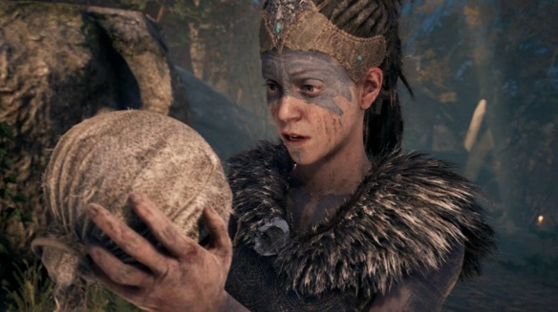The second key motivator is that of games that we have previously played that really caught our eye and creative edge when portraying difficult topics such as mental illness. The best example of this that springs to mind is a game called Hellblade: Senua’s Sacrifice (Ninja Theory, 2017). Hellblade covers mental illness from a very forefront position, using constant chatter and ramblings to full effect to help portray a heroine fraught with pain and suffering. This game was an experience, as it considered a medium as confronting as mental illness and loss, using this medium to create an experience that has been rarely seen in the video game industry to date.

Finally, the third motivator would have to be the varying portrayals of mental illness that is present in pop culture today. This includes but is not limited to characters and portrayals seen in the likes of Alice in Wonderland by CS Lewis, the Joker from the Batman Comic/Animated/Movie series’ and the movie Fight Club, just to name a few. Video Games are a medium that I believe are severely underused when it comes to the portrayal of mental illness, due to being a medium that forces active participation of the “player” in a setting built around a story setting. As a story telling medium, Video Games can create scenes and scenarios that are unique in storytelling, especially when being compared to mediums such as novels, movies and tv shows. Being able to create choices, follow your own path in a story, and build your own story based on environmental interactions are something that can truly only be brought to fruition using video games.

**Description**

To begin, the setting idea is that of a more modern era, centered around an office worker with a family. The setting should be representative of a normal household, and loving father or mother, that works day in and day out in order to put food on the table. Initially could sit in a setting where the husband and wife are arguing, creating initial tension and setting up a scene where the heroine leaves the house and goes for a walk down the street. This could set up the first point of negative voices.

Throughout the experience, I would want to try and use an irregular, yet invisible, voice to act as the game’s main enemy/antagonist. The idea is that the further you progress through the story, the more surreal the voice and its questions become. As a player, you will witness the progression of these events first-hand, initially starting out as family arguments with a little emphasis on the constant “voice in the head”, gradually turning into a battle against the characters own self-deprecation.

As far as in-game mechanics go, there would be a couple of points that would help make the experience more “realistic” as such. The constant chatter from the “voice” would be a focal point of the game, so using full 360-degree microphones to try and match the in your head mentality would be required. It would only be one singular voice, the characters inner mind. The voice isn’t always going to be totally negative either, there will be moments where it can be somewhat motivational, at points in the story when the player is slowly getting through a hard time or has succeeded at something. It is normal for people to praise themselves after all. But this can also then be used against the player, use them to create situations that might feel as though they will lead towards a better outcome.

Which leads me to my second feature in the game, false and misleading choices. Giving players a choice, or at least seemingly so, is a staple for a well-constructed single player campaign. However, in this instant, this entire notion is to be built in a way that may not be entirely “fair”. Either crafting options at critical points in the story that are either choosing from the lesser of multiple evils, or having the player select from a set of options that have a mix of good and bad responses. However, if the “good” responses are selected, the voice comes back and changes the decision, the voice line to that of a more detrimental affair. Because when you are down, it really is all in your head, and I want to portray this to as an extreme level as possible while keeping the scene of a normal, almost happy looking character or heroine alive. At least, initially so anyway.

Finally, to match with the choice option I just went through, I would like the game to have at least a few different possible outcomes. This not only assists with replay ability, but also opens the game for further, more permanent, and pivotal story points to occur that feel like they have meaning.

**Tools and Technologies**

After doing some research into engines that are actively available for upcoming creators, we believe that the use of Unreal Engine (Epic Games, 2019) would be a good base to run the game from. It is a very well-known engine that operates through C++ as its base coding language, allows for full visual importing of scenes and graphics, and allows for full control and creation of a video game from within its bounds.

Unreal Engine also has a large array of actively available learning tools, videos and articles that would allow amateur creators to slowly learn there way around the system, and therefore caters to individuals of varying levels of knowledge. Along with being an engine that is freely available to use, Unreal Engine has many free to use assets to build scenes and create the basis of a game that would be extremely beneficial for the creation of this project, as we are a smaller team. The less that must be made in-house in relation to prop and texture creation, the better. At least, initially.

And finally, Unreal Engine has its own in-built lighting system that is rather remarkable. The idea for this game would make use of low-lit environments, and specific lighting-based cues to build tension and create an environment of loneliness that will play heavily into the games overall feel. As at this point writing a lighting system for another engine would not be feasible, having this function openly available right out of the box means that the game can really show off it’s true, dark, colours.

You would also need suitable computing power to render the game, microphones, and tracking hardware to create human-like characters in-game. Being a game that would be heavily story-based, creating realistic characters with voice-acting would be absolutely required. This would require skills, time, and money that we don’t currently have available, however if this game were to eventually come to fruition, they would be musts.

**Skills Required**

Knowledge of Unreal Engine, C++, graphic design, sound engineering and storyboarding would be the main basic requirements for the job. There would not be too much in the way of specialist equipment that would be required however, as video game creation is a rather active field with readily available gear. Motion capture equipment would likely be the most specialized equipment that would be required. Finding assistance in the form of external developers, sound engineers, actors however, would most likely be necessary for the project to truly come together cohesively, or at least sooner rather than later.

**Outcome**

The general outcome of a project of this scope would be to try and create further understanding of the tough topic that is mental illness, no matter how insignificant it may appear on the surface. The outcome at the end of a playthrough would be one of the players creations, depicting an ending based on choices created throughout gameplay. To reiterate, the end impact that this game would be intended to have, is one of further understanding into the mind of someone that is fighting against them. Because mental illness is nothing to squander at.

**References**

Epic Games, I., 2004-2020. Unreal Engine. [Online]

Available at: <https://www.unrealengine.com/en-US/>

[Accessed 14 September 2020]

Limited, N. T., 2002. Hellblade Senua's Sacrifice Official Webpage. [Online]

Available at: <https://www.hellblade.com/>

[Accessed 14 September 2020]

*The Dark Knight.*2008. [Film] Directed by Christopher Nolan. America: Warner Bros. Pictures.

Carroll, L., 1865. *Alice's Adventures- in Wonderland.*United Kingdom: Macmillian.

*Fight Club.*1999. [Film] Directed by David Fincher. America: Fox 2000 Pictures.

Group Reflection

**Individual Reflections**

***Jake:***

I have felt from the start that we have a great group and I think it probably comes from the fact that we are group 1 and were the first to put out hands up to start a group. We communicate very effectively via our WhatsApp chat and have used this for our main form of communication rather than Teams. We work cohesively together and as time goes on it becomes more apparent where each members strengths lie and in what areas we can help each other more.

I have to say that I don’t think anybody was really prepared for how busy we all are in our personal lives and it has been hard to get everybody together to meet. I think now that we are more familiar with each other, we will be able to get started a bit earlier on our next group assignment and would probably benefit from just scheduling regular meetings from the start and just stuck to them and ran them for whoever could attend, rather than trying to postpone and reschedule.

Considering my nature, I was surprised by just how much I have enjoyed group work and working with new people and I feel really fortunate to be a part of such a proactive and friendly group. Through this group assignment I have learned just how very hard it is to organise six people to meet considering everybody’s different work, family, life and study commitments.

***Murray:***

I think the group did a really good job of coming together quickly and it was nice to find out that the group was awesome. Everyone was quick to put their hands up to do work, so it made it easy in terms of organising the workload.

Next time I would like to get a to do list going earlier in the project. It would have been good as it is always nice ticking things off a list. I also think that we should probably have organised all the Teams meetings at the start, to be attended and recorded by those that could make it.

I was surprised with how busy everyone in the group is outside of uni. It was comforting to know I was not the only one. It was also surprising how close the group got so quickly! Getting to know each member on a more personal level was really rewarding, especially in these times of Covid19.

I think this assignment was a good first step in getting to know our group and the small ways we can improve. More importantly though, we found how strong we are as a group and have gained the confidence we need to ace this and future assignments.

***Sneha:***

Not often have I come across this in team settings, but one of the things that we as a team did well was the way we collaborated and recognised everyone's strengths and weaknesses. Very early on into this assessment, we focused our energy on planning what needed to be done, structuring the contend, and assisting each other when one of us was struggling to complete a task.

One thing that really surprised me while working with the members of the team is how well each we work together. Each member of the team is so easy-going, considerate and willing to lend a helping hand where another team member is not able to complete a certain task. Given that mode of study being solely online, I was concerned about being able to interact with other students and being able to gain exposure as you would with on campus learning. But I must be honest I was truly impressed with how quickly each member got comfortable with each other. From the very beginning we created a WhatsApp chat group. On-going communication keeping all members in the loop as to where we are at really helped to build a strong team bonding.

One area we could improve on would be to organise a to do list at the earliest possible, assign tasks to team members with a tentative completion date. Doing this would mean that everyone would know the tasks they needed to complete within a certain timeframe. Overall, this project has taught me that teams can operate effectively regardless of individuals being in different locations and time zones. Our team was a prime example of this given that we have members from Adelaide, Melbourne, Sydney, Perth.

***Raj:***

Being part of this great team is a phenomenal feeling. I think, strength of my team is effective communication and engagements. All of my team members accepted the differences and helped each other to clarify and recognize the challenges of the tasks to achieve the goal, didn’t hesitated to appreciate for a team member’s hard work or contribution.

Good communication is the strength of my team; team members are extremely happy to express their ideas, suggestions and asking and giving feedbacks from the beginning. Regular meetings through Microsoft team, chats through WhatsApp increased the team productivity.

I noticed one thing, all my team members are rich with their hardworking, dedication, and pleasant attitude and a helping heart! Everyone took outstanding efforts to know each other. Everyone was clear about their role in this group activities and they contributed their part on time with perfection, work together superbly to accomplish great results. Everyone is so generous to share the workload and that made things bit easy. Great thing is that none of them are bookworms; they are a bunch of funny and joyous people, that reduced the stress of teamwork. I feel so proud to work with a supportive, friendly, target oriented team like this. I learned about how beneficial is to work with team members from diverse background.

***Ben:***

Right from the get-go I have felt extremely positive about the group that we had created. Each individual person within the group chose to find a group early on, and in doing so we seem to have managed to get a group of enthusiastic and motivated members together in which we can complete this project with.

Communication between the group has been great, with messaging back and forth with plans laid out early in the piece so that we all understood where we were going and who was contributing to what area. This if anything was what surprised me the most, as I have had group work in the past that has ended abysmally, with no co-ordination and work getting completed. This has not been the case here at all, which I have found refreshing. Group work can be difficult, and one thing I have learnt is that even though co-ordinating a large group can be difficult, it is not impossible.

Along with working with a group of people that reside all over Australia has been a final challenge and difference that I have found interesting, and if anything I am just surprised by how well we have managed to co-ordinate everything together. I have enjoyed working in this group and being able to make the most out of everyone’s own talents has proven to be fruitful for all involved.

***Jordan:***

I am very glad to be in this group. Each member of the group has different skills and strengths that have benefited the whole group in successfully completing this assignment. Everyone pulled together early on and started a good little relationship with everyone, which made working together so much easier. We could have been a bit more organised with meetings at first, but everyone took charge in their own way and made it happen. Working around our busy schedules has sometimes been a challenge but everyone has done their absolute best and I am very proud of each one of them and I am very proud to be a part of this group. I only wish my schedule had allowed me to contribute more.

Reference List

16personalities.com. 2020. *Nature: Thinking Vs. Feeling | 16Personalities*. [online] Available at: <https://www.16personalities.com/articles/nature-thinking-vs-feeling> [Accessed 13 October 2020].

Burning Glass Technologies. 2020. *Burning Glass Technologies | Real-Time Job Market Analytics Software*. [online] Available at: <https://www.burning-glass.com> [Accessed 13 October 2020].

LinkedIn. 2020. *Linkedin: Log In Or Sign Up*. [online] Available at: <https://www.linkedin.com> [Accessed 13 October 2020].

Emtrain.eu. 2020. Learning Styles Quiz. [online] Available at: <http://www.emtrain.eu/learning-styles/> [Accessed 13 October 2020].